Serial Number Label (Oct 15 proto units)

9/16/2014

The rear side serial number label shown is intended for the Oct 15 Alpha 2 proto units. The text on the label is for example only. Please submit any changes you feel are necessary. The production label will have the text and symbols needed for the regulatory purposes that apply.

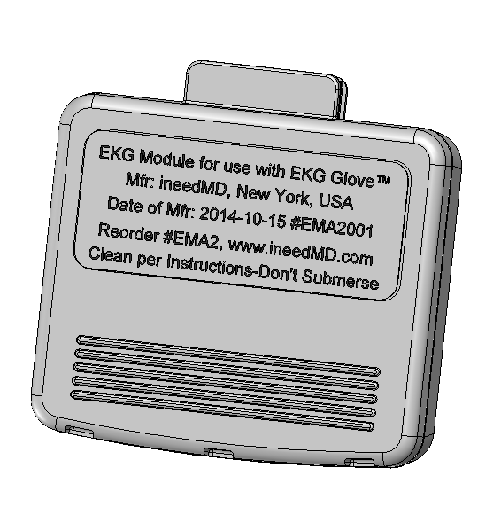

Front Logo Label (Oct 15 proto units)

9/16/14

For the Oct 15 A2 proto units, the front label will indicate the module is a prototype and not for patient use. The white color shown is due to having only a white background logo artwork available at this time.

